De Montfort University

Dobble Report

Multiplayer Real Time Simulated Card Game

Connor Rowland

P16204361

16/03/2019

CONTENTS

ABSTRACT: 3

INTRODUCTION: 3

RESEARCH: 3

DESIGN: 5

IMPLEMENTATION: 5

TESTING: 8

CRITICAL EVALUATION: 9

CONCLUSION: 9

APPENDICES: 10

# ABSTRACT:

This project converts a card game, called Dobble into a real-time simulated multiplayer game, which can be played by people all around the world. It covers the process taken to research and construct the different elements of the game. The resulting game works as expected, but with more features implemented than had originally been planned.

# INTRODUCTION:

This will outline how certain tasks have been met, my justification and reasoning behind my design decisions, how I managed the code, over the project’s lifetime, using an agile development technique known as test driven development (TTD), how testing was performed, future improvements, and the process of researching different aspects of the project to understand how to implement it. The motivation for this project was to improve my understanding of how real-time simulated multiplayer games are structured, and how the multiplayer aspect is added to different games.

# RESEARCH:

I decided to research the core areas of the project, as shown in Figure 1, such as: how to generate finite planes, to generate the different symbols on the cards, how to pack these symbols into the card’s area, different engine architectures that could be implemented, and how to implement the multiplayer side of the game. I chose these areas as I wasn’t too familiar with them and knew the research would aid my project’s development immensely – these are areas that had to be thought about and investigated to create the project.

Once the areas of research had been decided I looked up different reliable sources and made a collection of them, that could be used, see Figure 18. I decided if they were reliable by the sources they cited, the writer’s background, reviews left by other readers, and how well it read overall.

Overall, the research had a massive impact on the project. The findings from each section helped in one way or another. The Engine Architecture section had the greatest impact due to the findings about Entity Component Systems (ECS) and Inheritance-Based Systems. I found that an Entity Component based architecture has countless advantages over an inheritance-based architecture, see Figure 1. This was the greatest impact because I had planned on using SFML (Simple and Fast Multimedia Library) for the graphics, system timers, and networking, but SFML’s architecture is deeply inheritance based, which means using it with an Entity Component System would be almost impossible, for the graphics at least, due to a single object storing all the necessary information needed. This is because Entity Component Systems split objects up into different components, these components represent an object when they’re combined, which is why it wouldn’t be possible to intertwine the two, and still get the benefits from an Entity Component System. Because of this I decided to do the graphics myself, using OpenGL, with an SFML window, without the use of SFML’s graphics library, as illustrated in Figure 5.

Another impact caused by the research was the use of a client-server architecture, opposed to a peer-to-peer architecture. This is due to the customization and security provided by a server, which cannot be replicated when using peer-to-peer – the server is authoritative, which means it gets the final say over the client, drastically reducing the likelihood of cheating, between players, and the game can continue to run if a client disconnects or becomes desynchronized, as the game is ran on the server, see Figure 1.

The research done on User Datagram Packets (UDP) and Transmission Control Protocol (TCP), to decide which one would be best suited for the communication between the clients and the server was compelling, due to all the factors that had to be considered, as shown in Figure 1. TCP has many advantages over UDP, such as error detection and correction, guaranteed reliable and ordered delivery of the packets, and it’s easier to use. However, UDP has two advantages over TCP which are the two most important for real-time multiplayer games, these two advantages are: a lower latency cost, and is as predictable as a communication protocol can be (TCP has some unpredictable behavior, in certain scenarios).

The project has a limited time, to be developed, and the amount of time needed to create and test a custom layer built on top of the UDP protocol would be too time consuming, see Figure 7, as it would require at least: reliable delivery; reconstruction of the packets in the correct order, to reproduce the (exact same) data; and error detection and correction code. For this reason, I chose to implement a TCP approach, but with Nagle’s algorithm disabled, so packets would be sent immediately, as illustrated in Figure 1.

Research done on the symbol generation, using finite projective planes, showed that for every two distinct points there must be exactly one line that contains both points, and the intersection of any two distinct lines contains exactly one point. The lines generated correspond to the cards, and the points correspond to the symbols, on the cards. A simple way to generate the lines (cards) and points (symbols on each card) in a finite plane is by using the equation $n^{2}+n+1$ where n is the number of symbols on the card minus one, as discovered in Figure 1 and shown in Figure 26.

There are many ways to pack shapes inside of other shapes, but I decided to research how to pack non-uniform circles (symbols) inside of a circle (card). There were many ways this could be done, but very few of them were real time. The algorithm that stood out randomly scattered the generated symbols around the card’s area, and iteratively moved the circles towards the center of the card, ensuring none of the circle overlapped. Then a heuristic would be used to optimize the layout of the symbols – increase the symbols’ sizes and try to use as much space as possible. Two heuristics were found, one would loop through every available point inside of the card, checking to see if there was any available space a smaller symbol could fit it, and the other arbitrarily chooses a line through the center-point or an area of circles and mirrors the circles at an axis perpendicular to the chosen line, seeing if there were any improvements made, as shown in Figure 1.

Finally, I also decided to research Dobble, to find out any helpful information that could be integrated into the game, to keep it as similar as possible to the original, making sure the rules were familiar to players of the card game.

# DESIGN:

Before any code was written I decided to create UML (unified modelling language) diagrams, and user-interface (UI) designs, as shown in: Figure 6, Figure 7, and Figure 8, to aid in the develop – having something to refer to when unsure helped me focus on the task at hand.

I wanted the user-interfaces to be minimalistic, simple, consistent, and navigable, as shown in Figure 4. For these reasons there isn’t any unnecessary information being displayed, to the player. I decided to use the window’s edges for general information, such as the player’s score, time, and the enemy’s score. And the back/leave/menu button, which navigates the player back to the main menu is consistently placed in the lower left-hand-side of the window.

When designing the UML, I considered the game engine’s architecture (ECS) and what type of that specific architecture I was going to implement, whether that be an object-oriented, or a data-driven design approach. As illustrated in: Figure 1, Figure 5, and Figure 6 I took the data driven approach, which meant the components became purely data (without any functionality) and were tied together by an identifier.

The game’s design uses shallow inheritance, so polymorphic data structures can be created, allowing child object types of a parent can be stored in the same container. I decided to store all the different component types, this way. If the different component types didn’t inherit from the parent component then each type would have to be stored in a separate container, without being tied to the rest, and a lot of code would have to be added/deleted to add/remove component types, but due to them being tied together they can be stored in a single container of containers. This container of containers can grow/shrink depending on the number of different types of components being stored, as each type gets its own container, see Figure 22.

As I was doing my own graphics I decided to create my own shape classes, to aid in creating simple 2D shapes. I started with an abstract base class, called Shape, which had all the generic information in, as seen in Figure 34: the position, vertex/texture data, it’s orientation, a potential colour, and the texture, if there was one. It had a pure virtual method called Render, which the child classes had to implement, as seen in Figure 5. Using the Shape classes as a parent two base classes were created: CircleShape, and RectangleShape. I also did this because I wanted to be able to use polymorphism to store pointers of the parent type, which pointed to child objects, so large containers of shapes could be stored, and all called together.

A similar approach was taken when thinking about the design of the different scene classes. The fist design had an abstract base class called Scene, which had all the shared properties for scenes, like the Shape class, for shapes, and pure virtual methods that had to be implemented by children classes, this meant an instance of Scene couldn’t be created, only child classes could. After some thought I decided to change this design, to make scene a generic (plain) menu class, which still stored all the generic, shared, data for scene, but it now implemented the virtual methods, instead having them as pure virtual, as seen in Figure 5. Due to there only being a menu options and basic text information being displayed in most of the scenes, except game, it reduced the number of classes necessary from 4 to 2, as I decided to replace the EndGameScene and HelpMenuScene classes, with the generic scene class – simplifying the design.

The only remaining child class of Scene was the GamePlacePlay. This class added a lot of additional data and functionality, used to manage the Dobble game, in progress, it added a client, so it could connect/communicate with the server, different post processing effect management variables, to activate the effects pseudo-randomly, for a pseudo-random amount of time, it managed the player’s score, and number of rounds won, as illustrated in Figure 5.

# IMPLEMENTATION:

I used an agile development methodology, known a test-driven development mixed with scrum. A backlog was made, illustrated in Figure 19, to keep track of the user stories (a task), story points (the amount of time it would take to complete the task), and the sprint weeks, which kept track of the project’s overall progress. The sprint weeks dictate when progress was going to be made on the project. The user stories were grouped into different sprint weeks, depending on when that functionality could/should be implemented – the tasks were set at the sprint review. I used GitHub’s Kanban project board to store all this information, as it is simple to use and could easily be modified, as seen in Figure 20.

There were five sections, on the Kanban board, which tracked the state of each user story: Implementation TODO, Testing TODO, In Progress, Refactor, and Done. These can be seen in Figure 19. During each sprint week the user stories would pass through certain sections – if it was expected to be done that week it’d be in the In-Progress section, if it had been done, but the code could do with being improved it’d be in the Refactor section.

As mentioned above, I used GitHub to manage the project’s progress/documentation, but I also used it to manage the code. I created an additional branch, so there were two branches, one called master, and the other development. When a sprint was in progress all the new code would be committed/pushed to the development branch, once the sprint was over, and the code had been checked enough it was pushed to the master branch. The rule was that the master branch must always have a working version, which could be downloaded and compiled/run.

To get a rough estimate of how much progress had to be made each sprint week I created a burndown chart, as shown in Figure 7. I calculated I had 8 sprint weeks, with a total of 615 story points, to get through. This meant I had to complete roughly 76.875 story points each sprint, to complete the project on time.

In the first sprint week I set up the game engine (client), server, and the unit testing projects; created a way to log information during runtime, to ensure everything ran as expected, and implemented a random number generator, as illustrated in Figure 2. I ran into issues when trying to set up the unit test projects because I attempted to change the directory of where the packages for the projects are stored, I’d rather have them stored with the project file, but couldn’t move it as it would create linker errors. I worked around this by storing the packages with the main (client/server) project files.

The second sprint week’s tasks were to implement the entity manager, entity components and entity systems, as seen in Figure 2. The first implementation of the entity manager had a component manager class, which stored different types of components, but the different types would have to be manually created as a type, and added, as the component class was templated. When accessing a component there’d have to be at least three branch jumps, due to the component being hidden underneath three get method calls. This was changed, and the functionality of the component container was moved to the EntityManager class, shown in Figure 21, so the components could be accessed directly by a single call. The component was also drastically changed, instead of being a templated class that could store an entity ID, it was changed into a base class, for components to inherit from. Because I wasn’t happy with the code, at first, and decided to rework it, making the design elegant, I fell behind schedule, by 68.75 story points, as I only completed 30 story points, development speed needed to accelerate, and more user stories/story points needed to be added to the sprint, see Figure 2.

As I was so far behind schedule, due to a lack of development speed, illustrated in Figure 2, I wanted to catch up a little with the third sprint week, so I added 100 story points worth of user stories to be completed, see Figure 19. The user stories included: add a resource manager, a way to detect collisions between different shapes, better understand how to implement the client/server communication, display the player’s card on the screen, resolve collisions, if any occurred, generate the symbols that would be placed on each card, and pseudo-randomly place the symbols on the card. I managed to complete every user story, but was still behind schedule, by 45.625 story points.

The fourth sprint week revolved around implementing the client and server communication, and finishing the card/deck generation, see Figure 19. I managed to complete everything, except the card generation. The algorithm and heuristic I researched, and implemented wasn’t real time, it could take up to 20 minutes to generate the deck of cards. The symbols were nicely packed, and the couldn’t be improved, but it wasn’t feasible, due the amount of time it took to generate the transform data for each symbol.

I had to come up with a new way to generate the transform data for the symbols, I started the same way, by pseudo-randomly generated the symbols rotation, which didn’t need to be checked if it was between a certain value because it’s a circle, then generating the symbol’s size, which was between a minimum size, and a maximum size, this varied depending on the card’s size, and didn’t matter too much, as long as it was smaller than the card because the algorithm might shrink it anyway, if it’s above a certain size, and in the way. Finally, the symbol’s position had to be generated, and was randomly generated inside of the card’s area. Due to the symbol’s position being completely random it had to be checked, to make sure it was placed in a valid position, it could fit in. A valid position is one where the symbol doesn’t collide with any other symbols, that are on the card, and is within the card’s area. Because of the unlikelihood that the first position generated for the symbol would be valid an iterative approach was taken. The position would be generated N number of times, if a valid position couldn’t be found within the Nth attempt a symbol on the card would be shrunk, and the process would happen again, look another N number of times, before shrinking another symbol, on the card, this is illustrated in Figure 23. The symbol chosen to be shrunk had to be above a minimum size, or else it would choose a different symbol, which was chosen depending on the order of the symbols (it’d loop through all the symbols on the card – first to last – shrinking each one, bit by bit).

By the fifth sprint week I was almost an entire sprint week behind, having fallen behind schedule by 62.5 story points. To reduce the gap between the estimated points, and the actual points remaining I decided to get as much done as possible, and focus on the getting a working game done, without any menu or user-interface, but it would have the core gameplay/mechanics implemented, see Figure 2. To have a working prototype a lot of small user stories had to be completed, as seen in Figure 19, including: sending the players their starting information, being able to check if a round is over, allowing the player to select a symbol with their mouse, and send it to the server as the player’s guess attempt, display the other (deck) card on the player’s screen, incrementing the player’s score that had won the round (it wouldn’t be displayed), checking to see if the game is over, and gracefully disconnecting from the clients, when the game is over. I managed to complete every user story, and have a working, bare bones, prototype.

Through this sprint week I discovered a couple of issues, shown in Figure 17: firstly, the server wouldn’t stop listening, for incoming clients, so players could join mid-game, secondly the server only acknowledged data being received from the clients, if the first client sent data, later I discovered that this was due to not using a socket selector, in an overloaded method, see Figure 24, finally, I found that the player’s mouse wasn’t aligned with the window, when it was resized.

The sixth sprite week was spent improving existing code; implementing the user-interface, and menu system, see Figure 19. I found it difficult to find images and (text) fonts for the menu backgrounds and button images that went well together, with a similar art style. I wanted something easy on the eye that had a personal touch. The results of the chosen images/font can be seen in figures: Figure 8 to Figure 16. A big improvement made to the code in this sprint week was the creation of the shape classes, before using the shape class[es] there were vertex buffer object and vertex array object creation/binding code riddled throughout the code base, but now it’s limited to the shape classes. I attempted to call the child shape classes: Circle and Rectangle, but that created a compile error, I assume it had to do with something else naming a class Rectangle. Instead of putting them in a namespace, I decided to change their names, and add Shape to the end.

Now that the game had menus, a user-interface, and game mechanics there wasn’t much left to do, but to check for runtime errors, and add: unit tests, to existing untested code; and additional features/mechanics. So, the two remaining sprint weeks added unit tests for: the symbol generation code, ensuring it generated cards that had only a single symbol match with any other card, in the deck; the transform, and render components, to make sure they could be constructed and passed to a packet directly, and to test the mouse input, ensure if a player clicks on a symbol it uses the symbol clicked on as the player’s attempt.

Additional features, such as: postprocessing effects, as seen in Figure 12, Figure 13, and Figure 14, particle effects, as illustrated in Figure 25, and game audio (background music and sound effects), as shown in Figure 27, were added. Improvements were also made to the packing algorithm, see Figure 28, to increase the size of the symbols on the card, once they’ve been placed in a valid position. Each symbol would keep increasing in size, until it collided with another symbol, or reached the edge of the card’s area.

Any remaining issues documented in Figure 17, were resolved. Notably the issue, where the framebuffer object would be recreated, when the window was resized, causing the post processing effect being applied to be reset (no longer active). The workaround for this was to stop the resizing of the window, so the player couldn’t abuse the reset.

# TESTING:

A test-driven approach was loosely taken to develop the game, which meant I would write test cases to test for some functionality, the test would fail, I’d then write the required code to make the test pass, refactor the code, and then move on to the next test cases.

I used Google Units tests, to test the code’s public interface, 175 tests were written, as shown in Figure 29, and Figure 30, the tests were split into two project, one that tests the client code, and another that tests the server code, 147 tests were written for the client’s project, and 28 for the server’s project to ensure every method worked as it should. The client had so many more tests due to it being the project that tested the shared code.

To set up the Google Unit test projects I created a duplicate of the game engine and server projects, and built them as static libraries, so they could be linked to the test projects, this reduced the hassle of having to link many different third-party libraries with the tests, as shown in Figure 31.

A problem that occurred when trying to write a unit test, to test the server game code was that on initialization of a server game object it would wait for the minimum number of clients to join, before creating the object (a method was called in the ServerGame’s constructor, which wouldn’t finish constructing the object, until the clients had joined). To overcome this problem, I had to use threading. A thread object was created, passing in a lambda function, which create the ServerGame’s instance, while the server game was waiting for clients the main thread would create the clients it was waiting for, so they could connect to the server, and the object could be created, this can be seen in Figure 33. Before using a separate thread to create the server game’s object I attempted to do it on a single thread, which caused the program to crash (stop responding), as expected, but it also stopped the project from compiling, due to a linker error – the executable couldn’t be found, yet it had been produced, and was working fine before the test. I attempted to clean/rebuild the project, but nothing fixed the linker issue. I then tried to manually delete the executable, but couldn’t because it was still active, which is when I found the reason as to why the project wouldn’t compile – it couldn’t delete and rebuild the executable, as the executable had completely halted doing anything but waiting for clients to join. Because of this I added timers to how long the client would wait to join the server, as the clients were created in the main thread, as they should be able to connect instantly because the server is already waiting for their connection request.

# CRITICAL EVALUATION:

# CONCLUSION:

In conclusion, the planned aims and objectives have been met. The result is a real-time simulated multiplayer game, which can be enjoyed by people all over the world. I learned a lot from this project: the different choices that must be made, when thinking about adding multiplayer aspects to the game,

# APPENDICES:

Figure 1) Literature Review.



Figure 2) Periodic Progress Reports.



Figure 3) Module Forms.



Figure 4) User-Interface Designs.

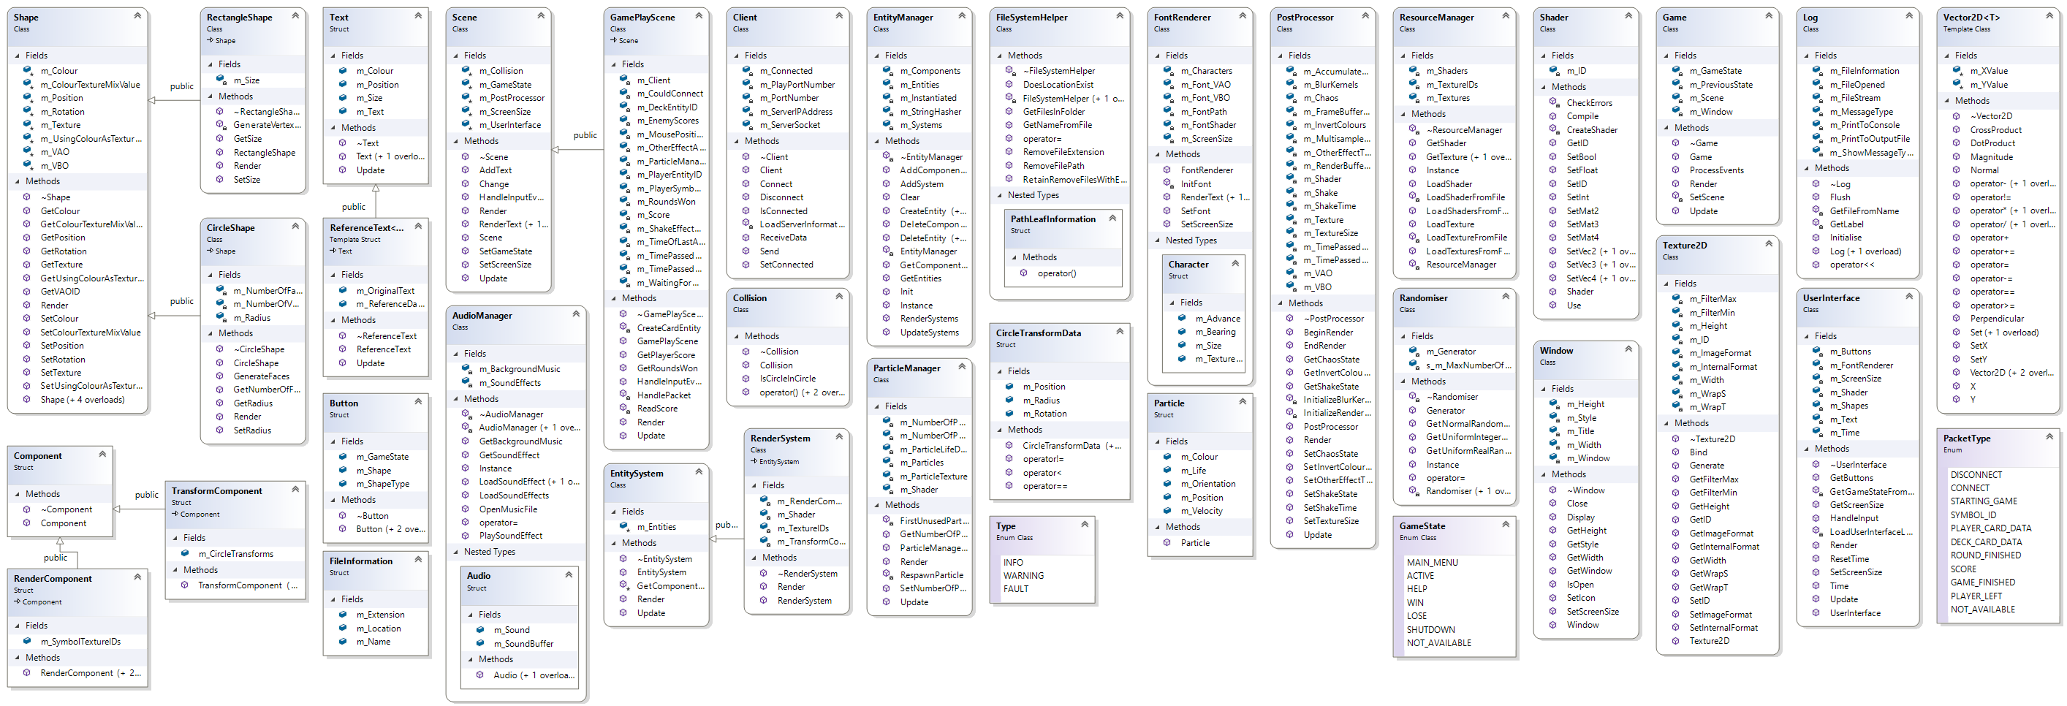

Figure 5) Game Engine UML Design.

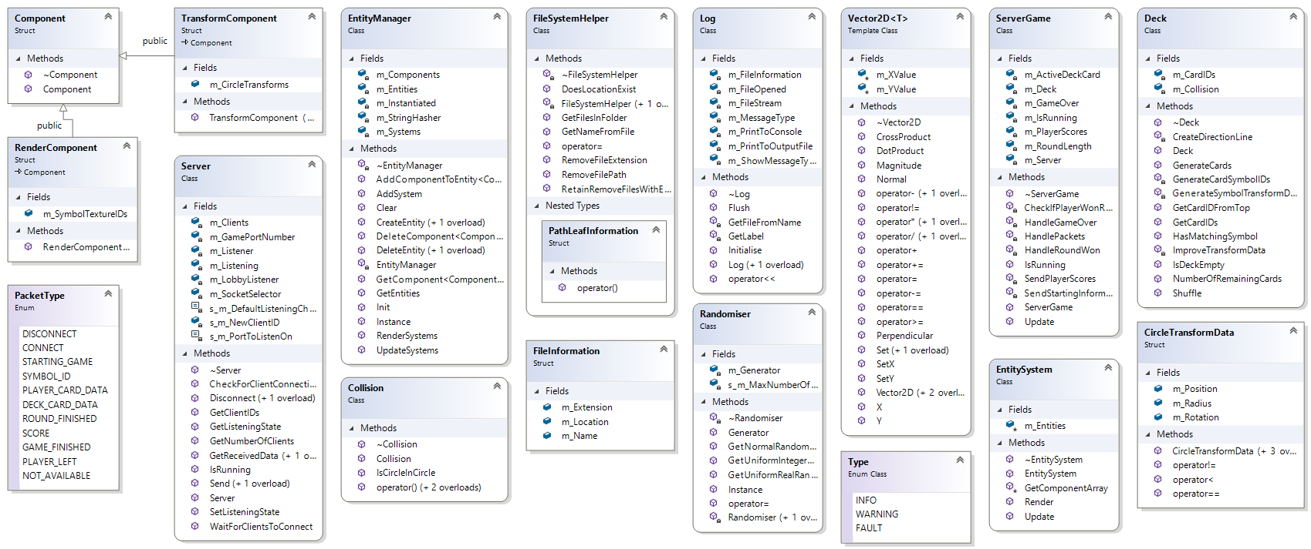

Figure 6) Server UML Design.

Figure 7) Project Burndown Chart.

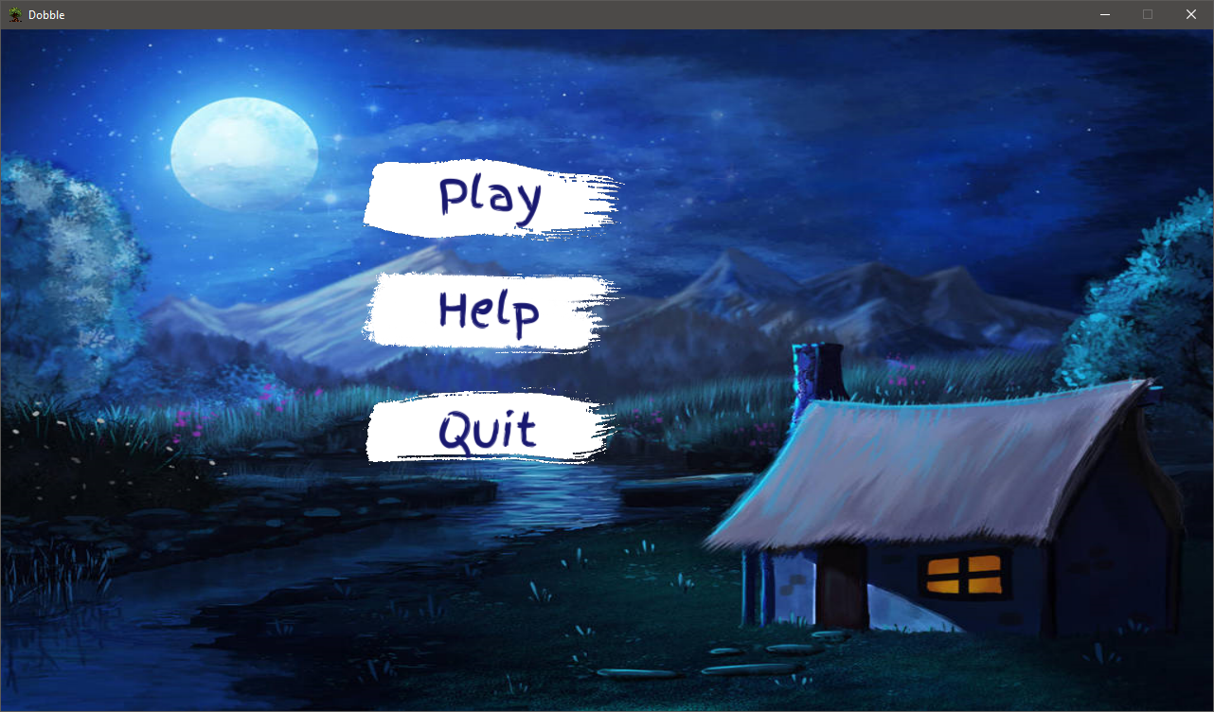

Figure 8) Main Menu Scene, from the game.

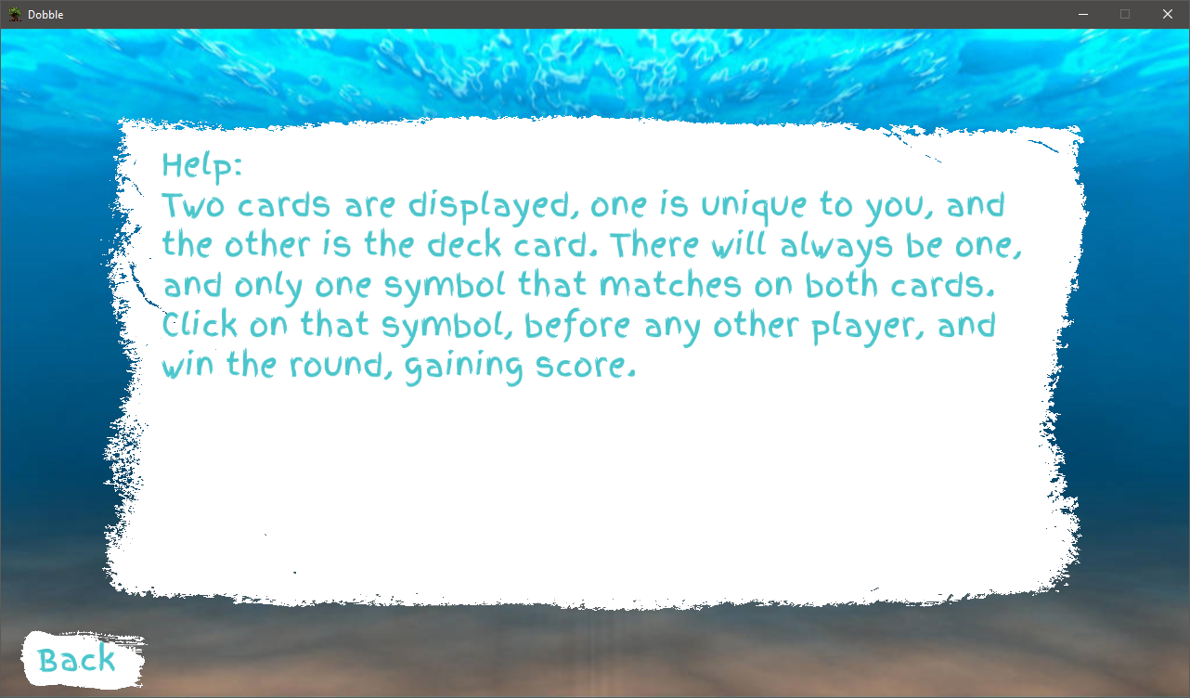

Figure 9) Help Scene, from the game.

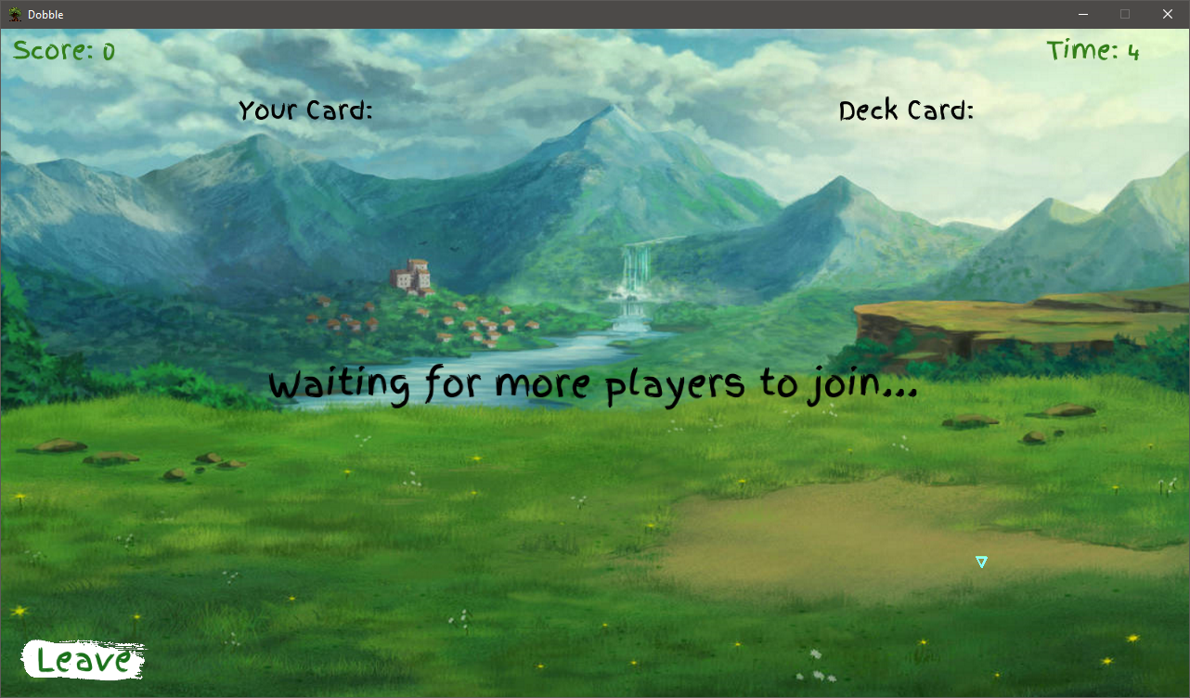

Figure 10) Game Play Scene, waiting for more players to join.

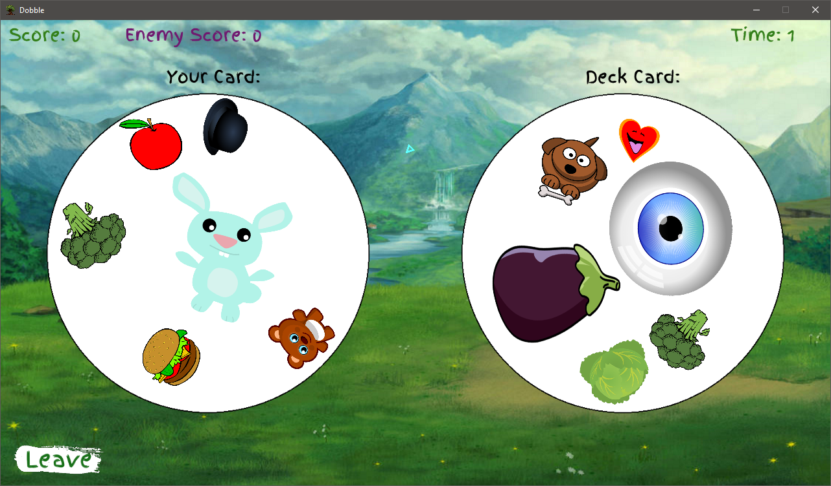

Figure 11) Game Play Scene, game has just started.

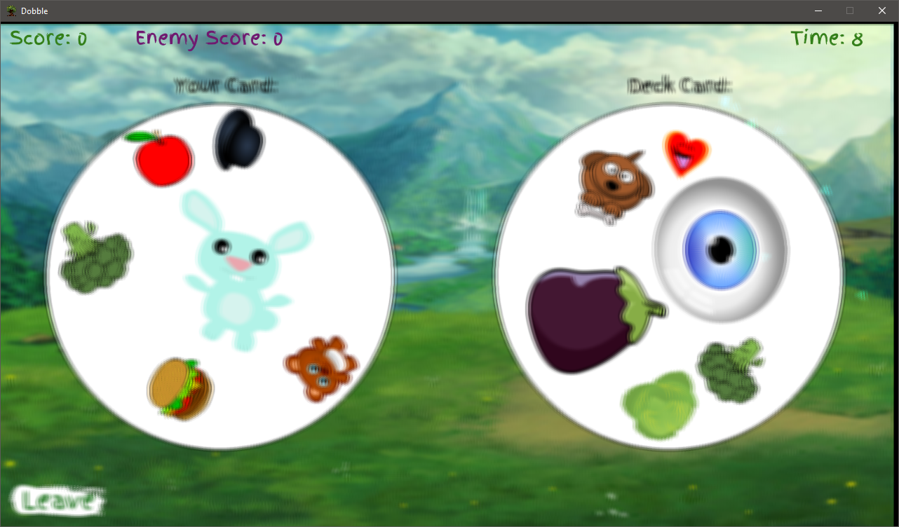

Figure 12) Game Play Scene, shaking effect has been activated.

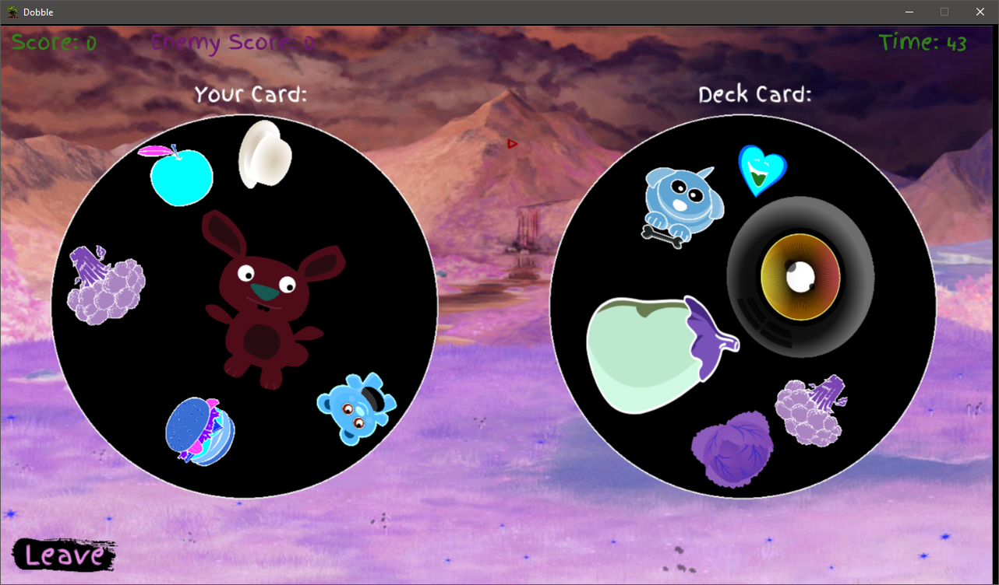

Figure 13) Game Play Scene, the inverse effect has been activated.

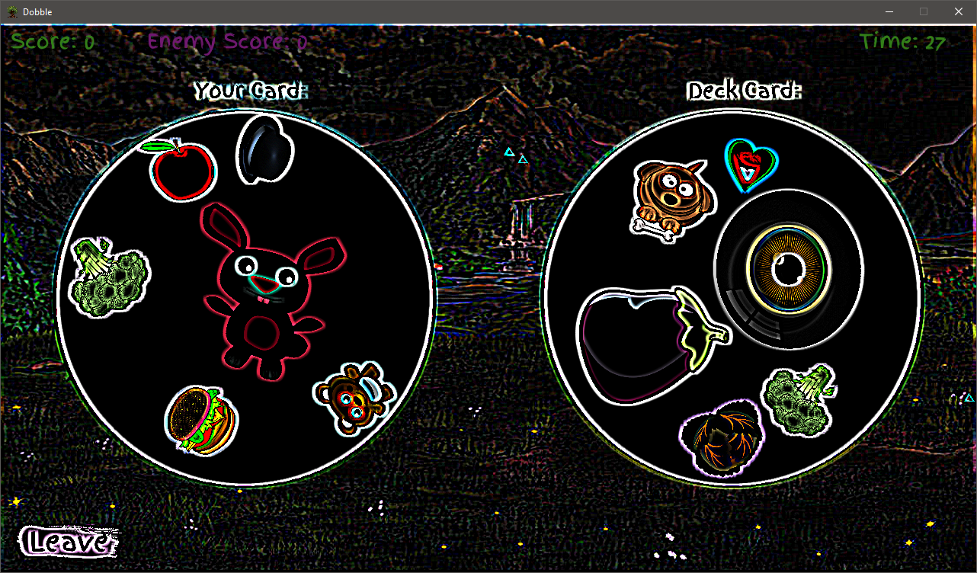

Figure 14) Game Play Scene, the edge kernel effect has been activated.

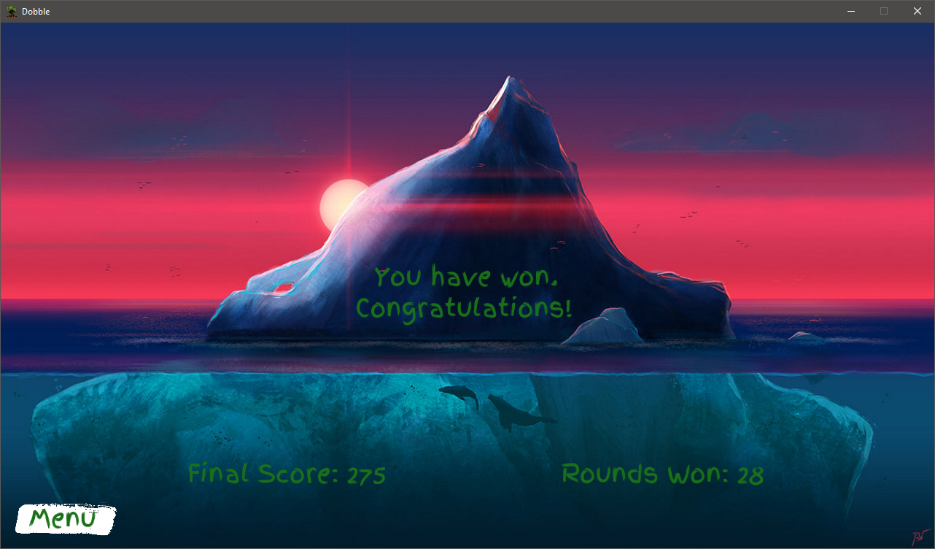

Figure 15) Game Over Scene, the player has won.

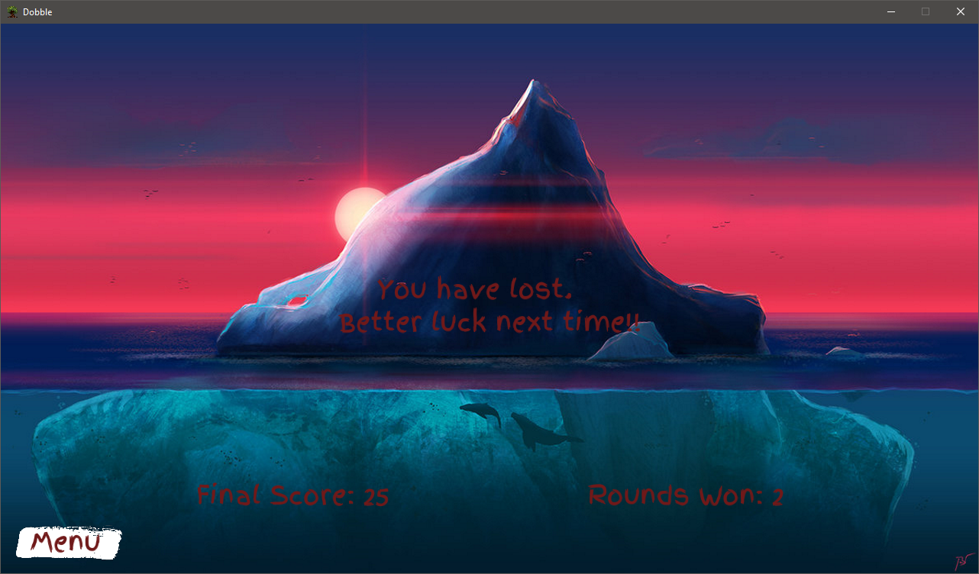

Figure 16) Game Over Scene, the player has lost.

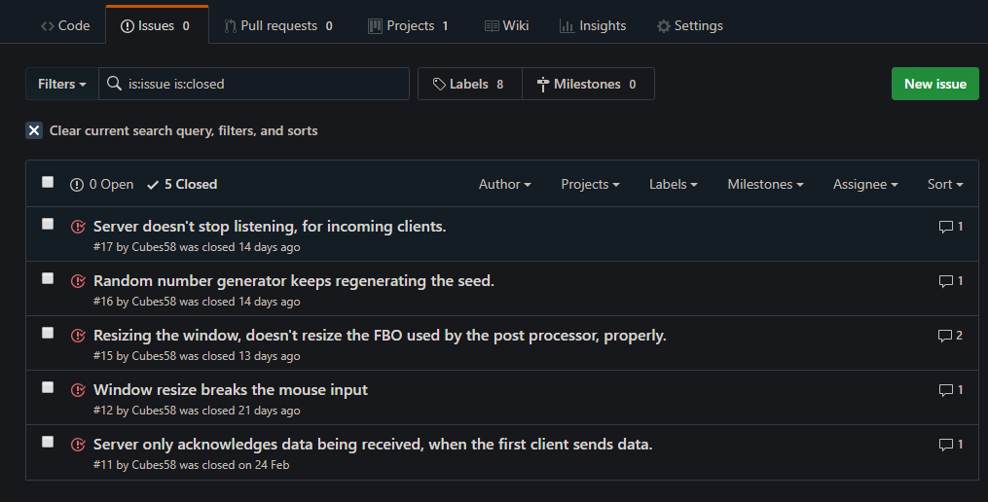

Figure 17) GitHub issue[s] management.

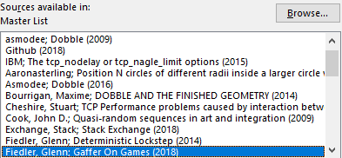

Figure 18) Reliable List of Sources.

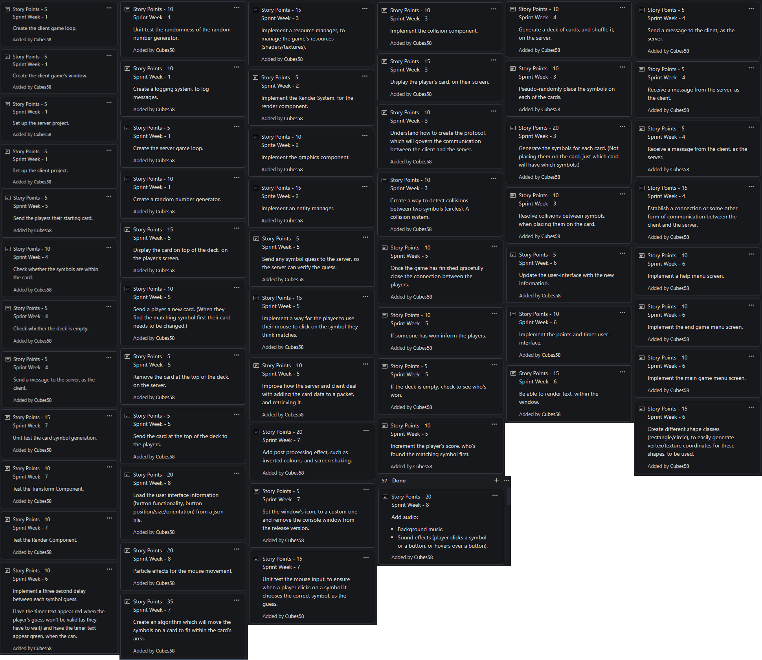

Figure 19) Story Board, of user stories.

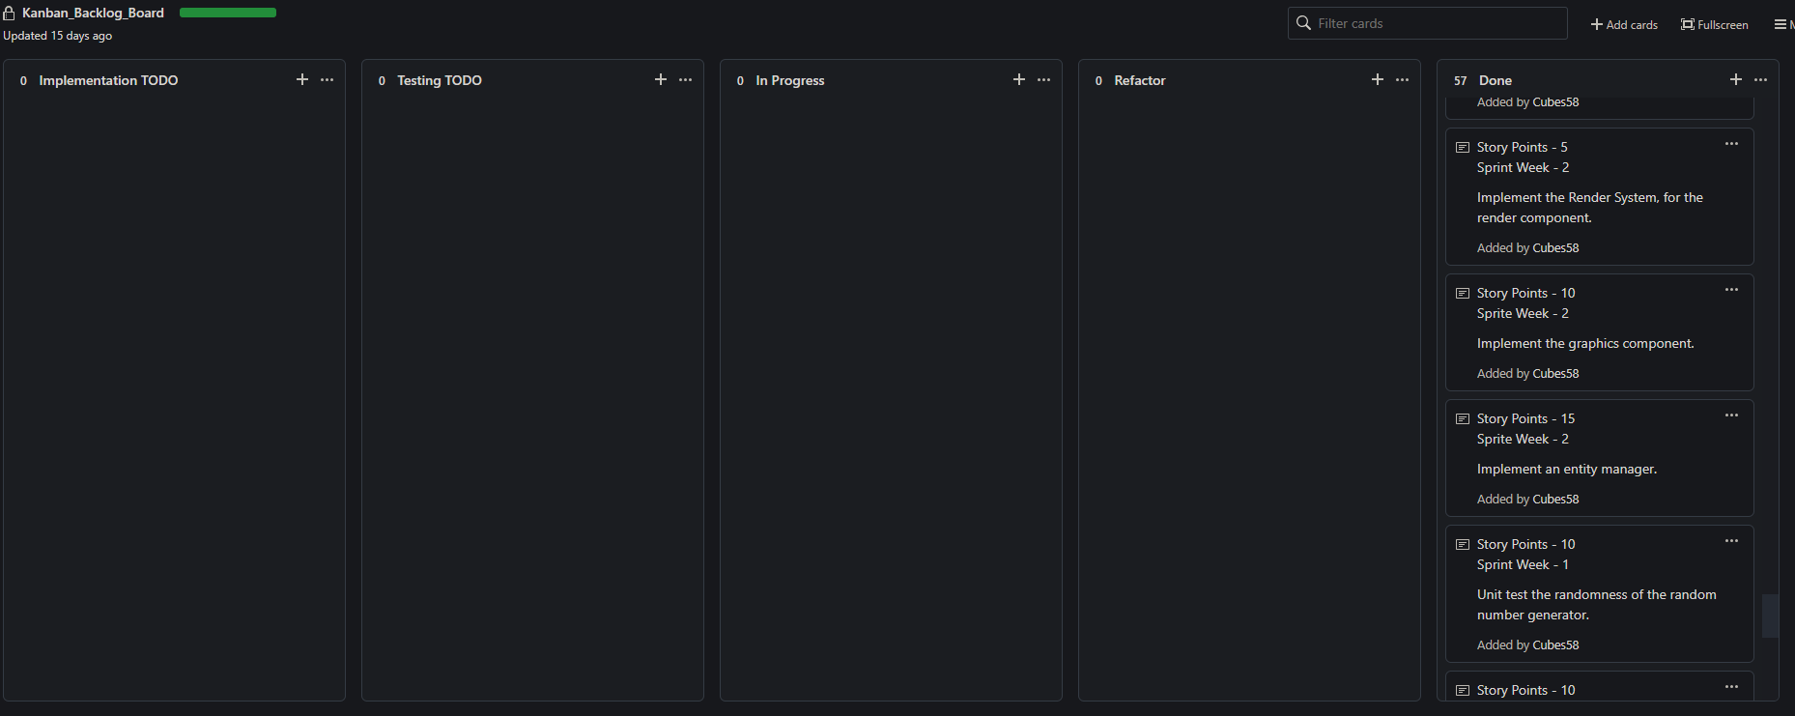

Figure 20) GitHub Kanban Board - End of Project.

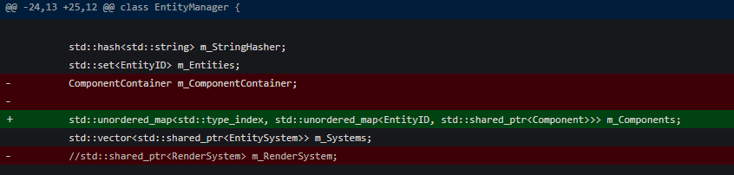

Figure 21) EntityManager change from ComponentContainer to a polymorphic data structure.



Figure 22) EntityManager - component/system properties.



Figure 23) Deck - Generate Symbol's transform data.



Figure 24) Server - Get Received Data.

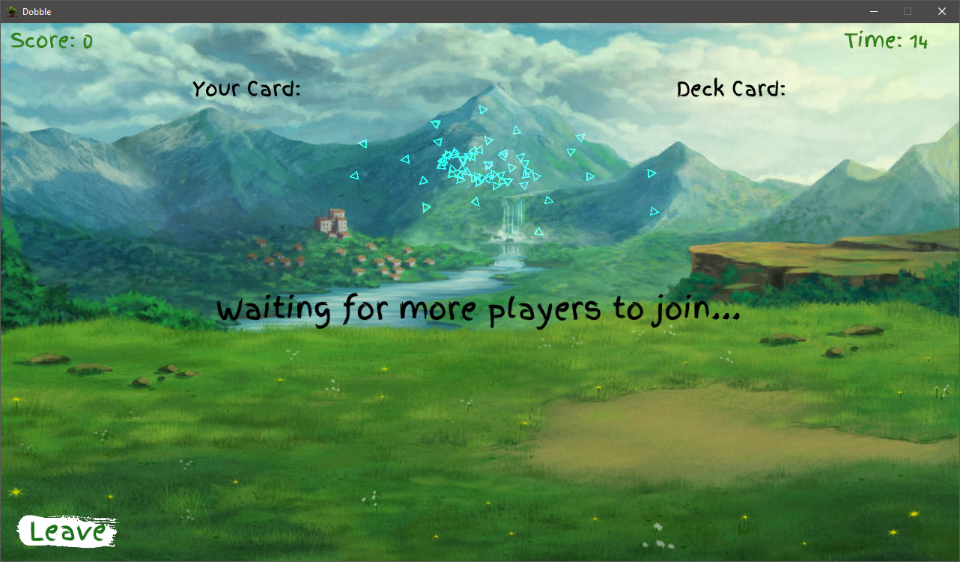

Figure 25) Game - Particle Effects.



Figure 26) Deck - Symbol ID Generation.



Figure 27) Game - Audio Manager properties.



Figure 28) Deck - Symbol improvement algorithm.



Figure 29) Game Engine Unit Tests Output.



Figure 30) Server Unit Tests Output.

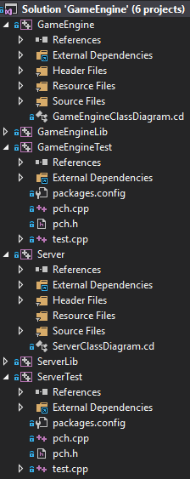

Figure 31) The Solution’s Project List.

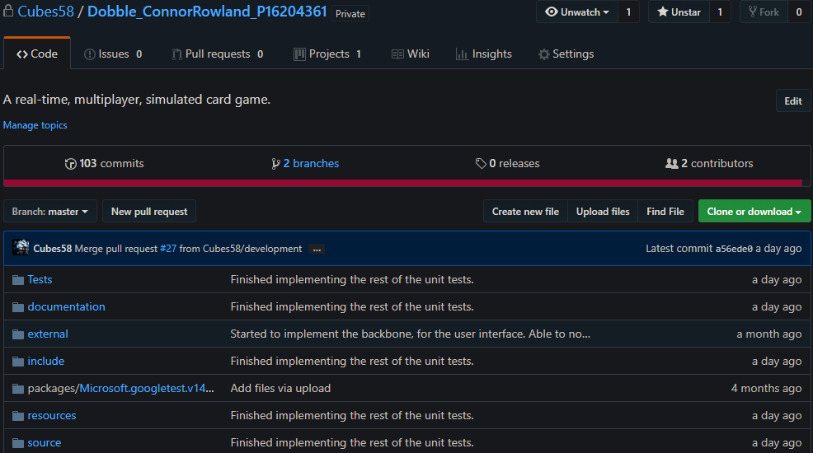

Figure 32) GitHub Repository.



Figure 33) Initialize Server Game Instance Test.



Figure 34) Attributes of the Abstract Base Class Shape.